**Objective**

The goal of lab 7 and lab 8 was to build and output and input amplifier circuit based around the LM386 capable of processing an input from a microphone and driving a speaker. The output amplifier consisted of an attenuator, into the LM386 amplifier and filter. The input amplifier consisted of a microphone into the amplifier and also a filtering stage.

**Results**

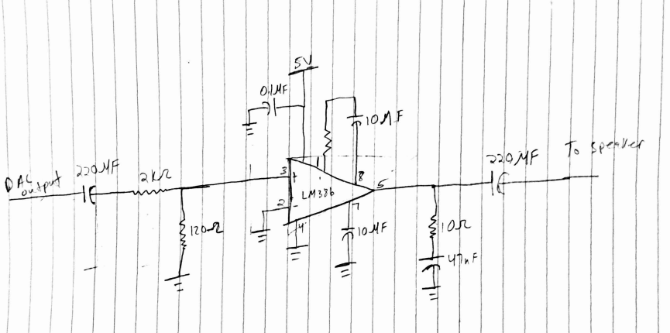

Figure 1: Schematic used for Output Amplifier

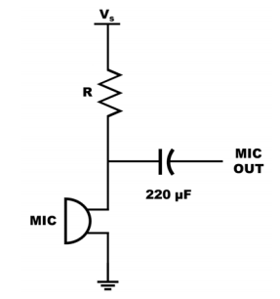

Figure 2:Schematic used for Microphone output

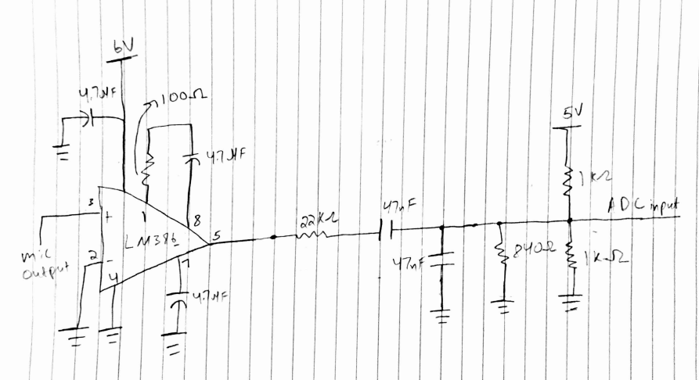

Figure 3: Schematic used for Input Amplifier

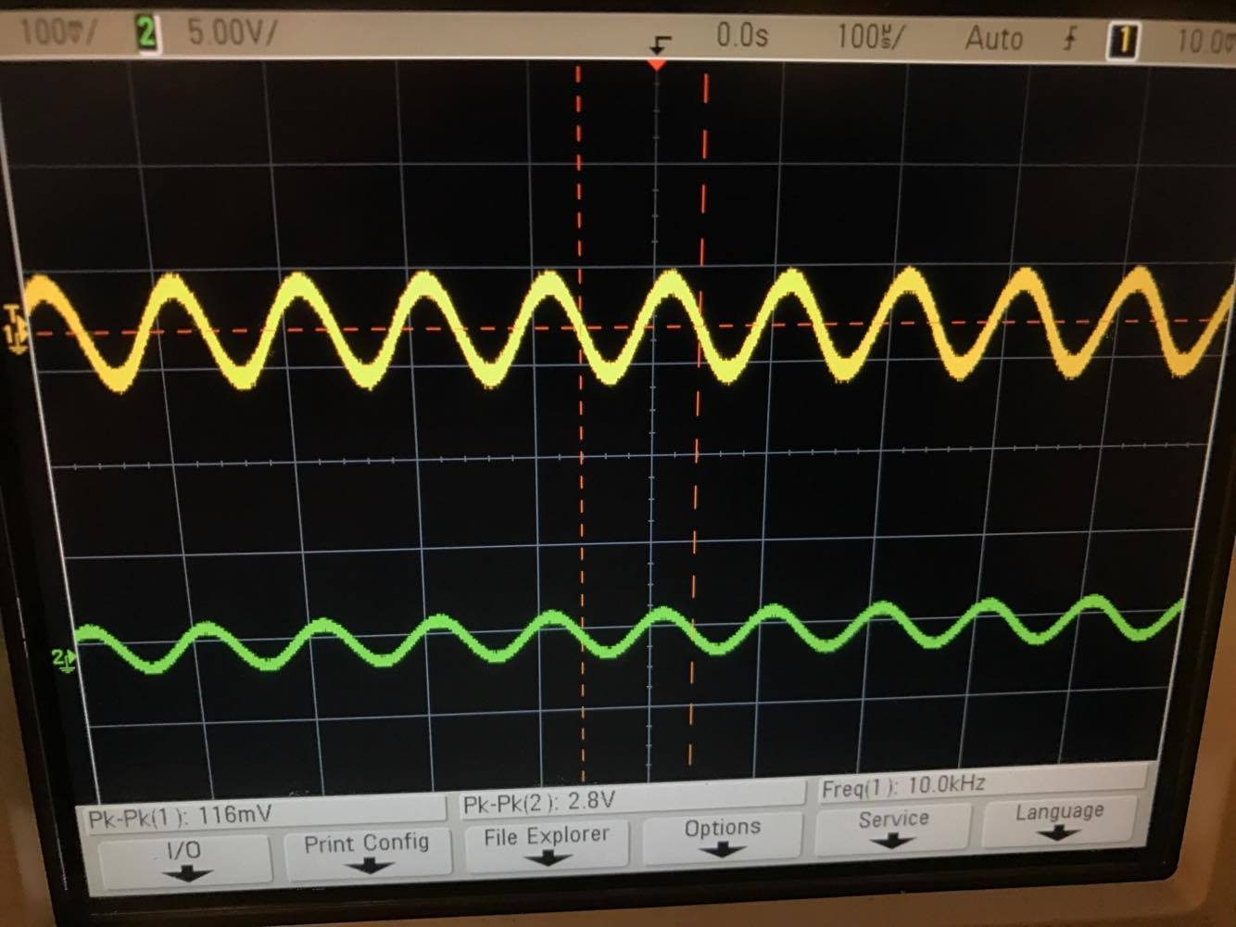

Figure 4: Gain of about 24 with 1kΩ Resistor

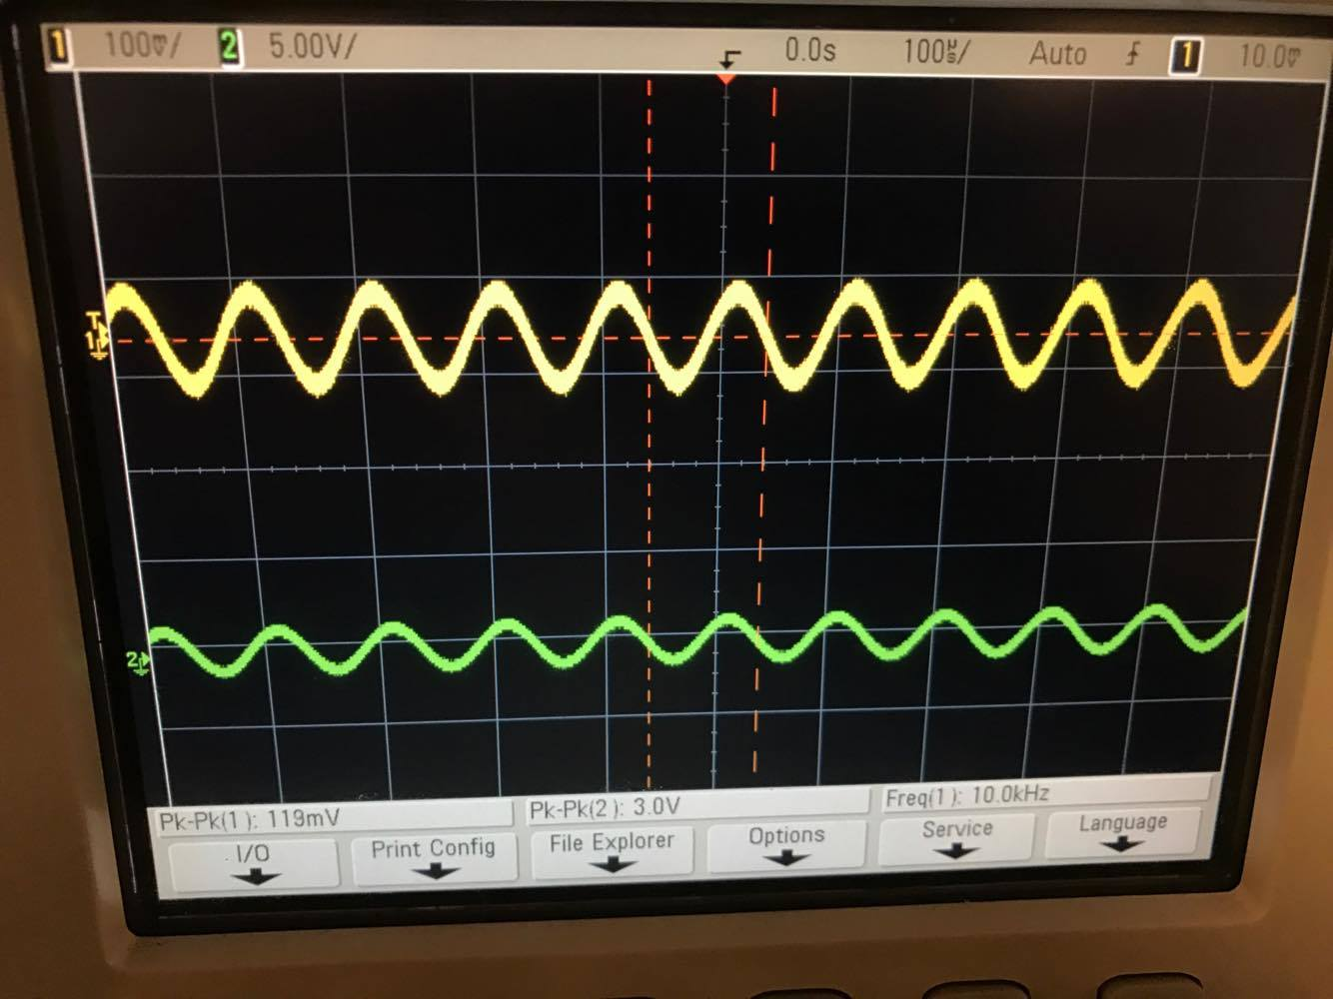

Figure 5: Gain of about 25 with 5kΩ Resistor

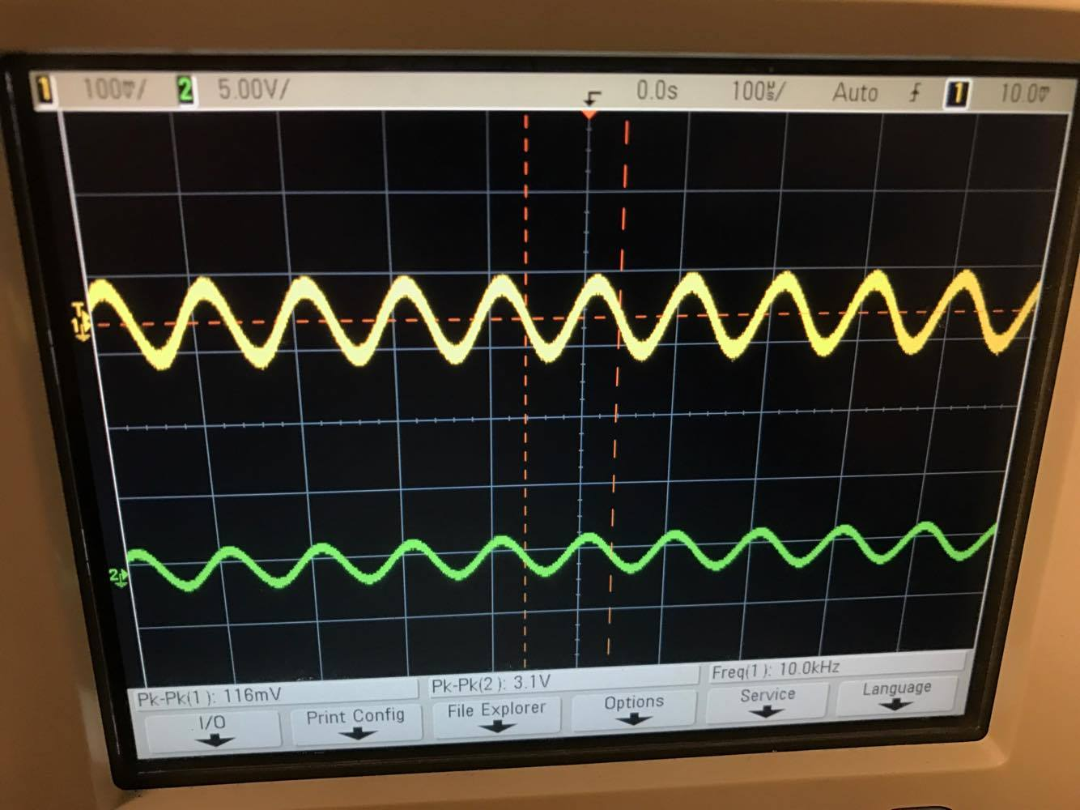

Figure 6: Gain of about 26 with 10kΩ Resistor

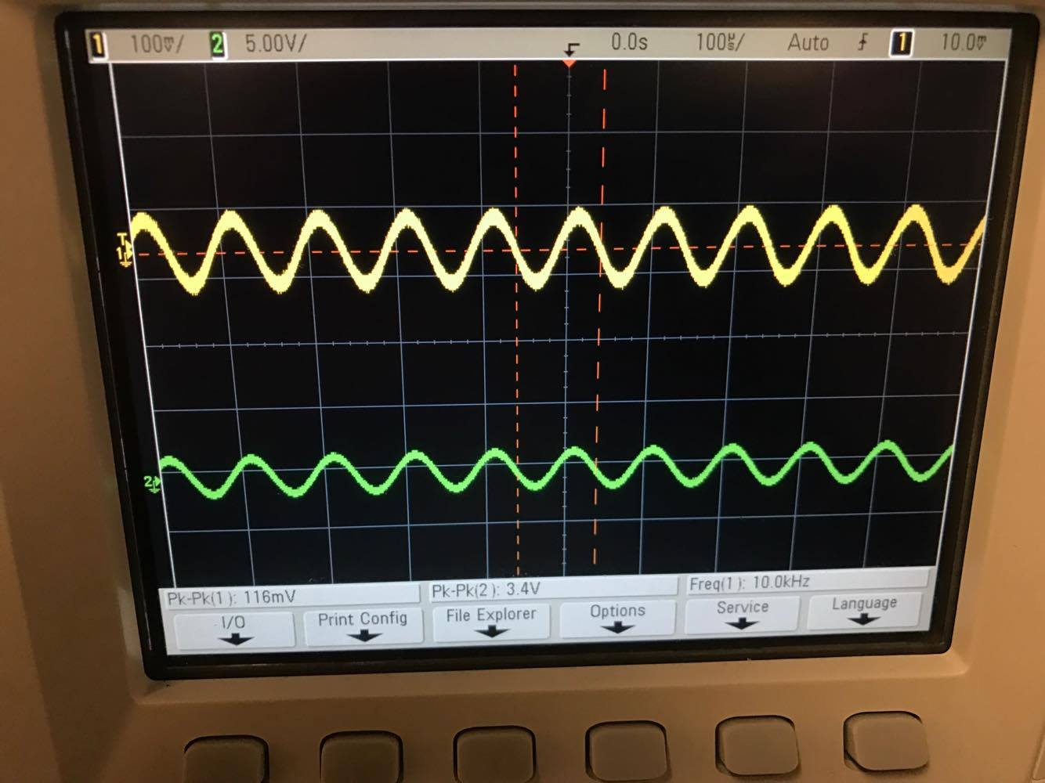

Figure 7:Gain of about 29 with 20kΩ Resistor

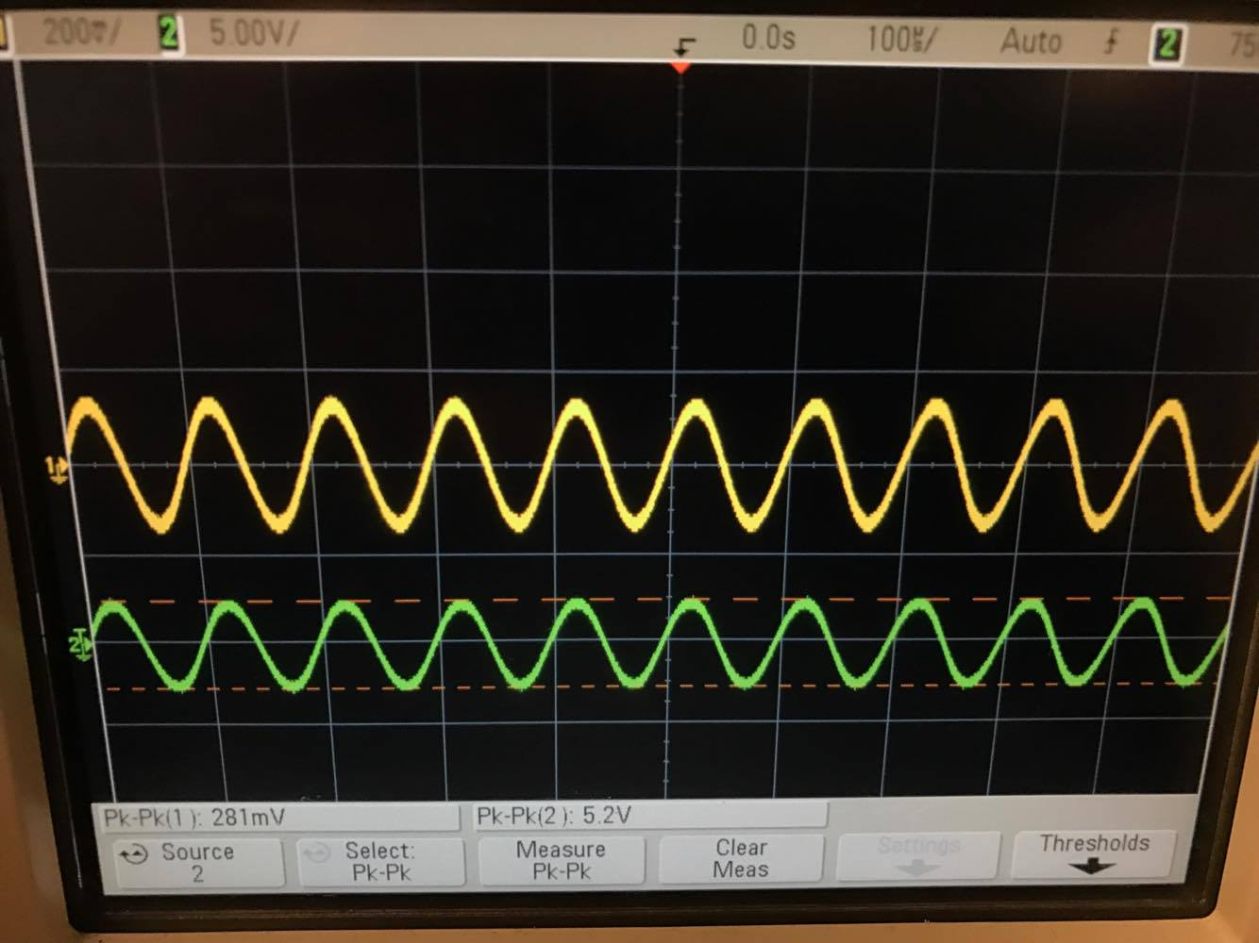

Figure 8:Gain of about 18 with 50kΩ Resistor

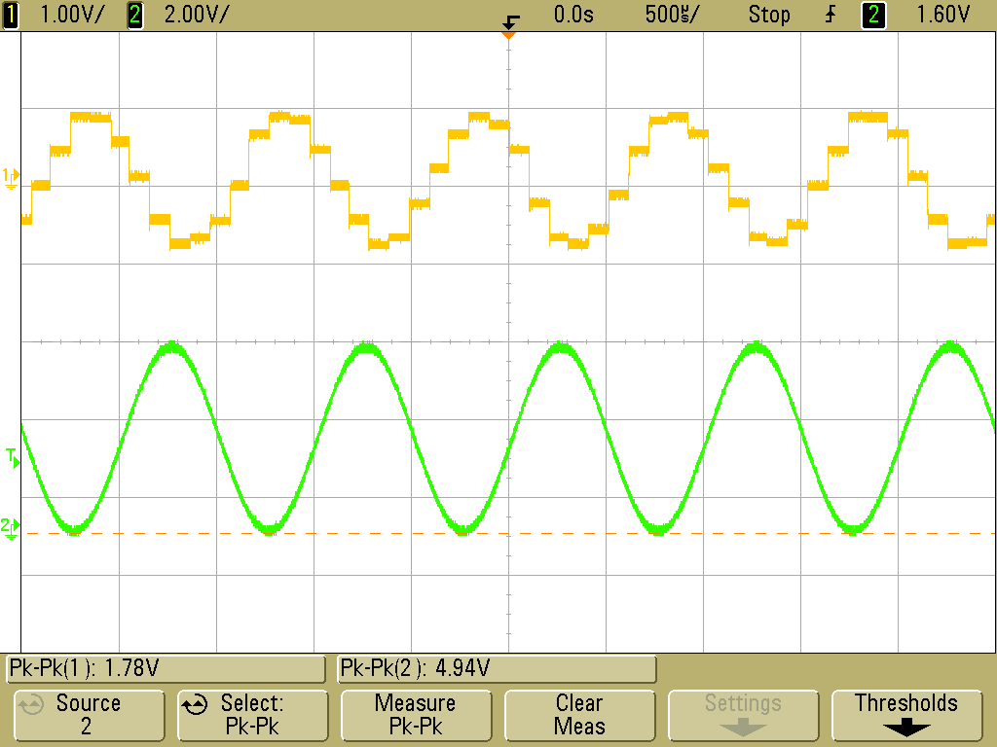

Figure 9:Output of Output amplifier with no filtering Green is input into Attenuator Yellow is Output of Amplifier

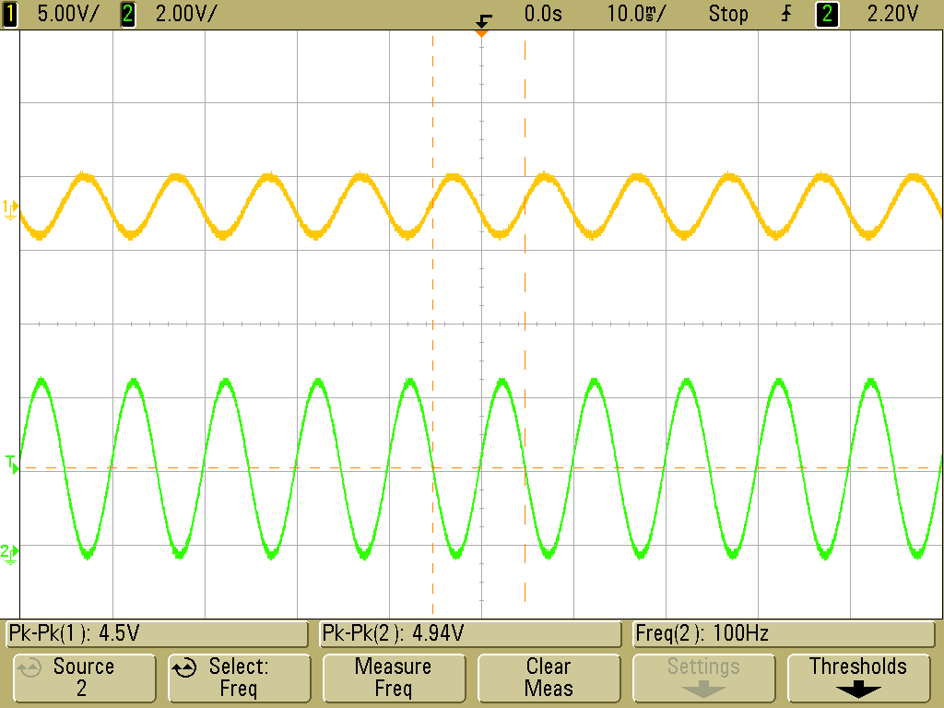

Figure 10: Output of Output amplifier with filtering Green is input into Attenuator Yellow is Output of Amplifier

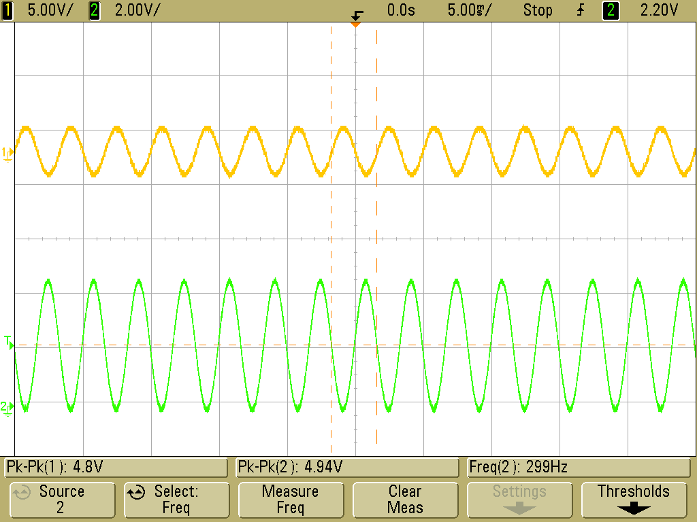

Figure 11: Output of Output amplifier with filtering Green is input into Attenuator Yellow is Output of Amplifier

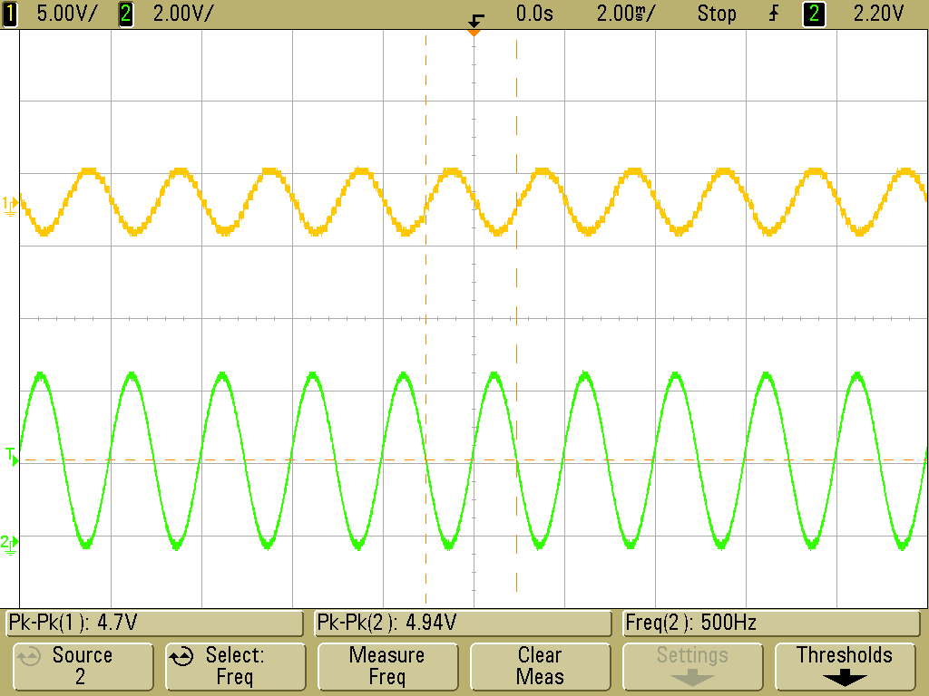

Figure 12: Output of Output amplifier with filtering Green is input into Attenuator Yellow is Output of Amplifier

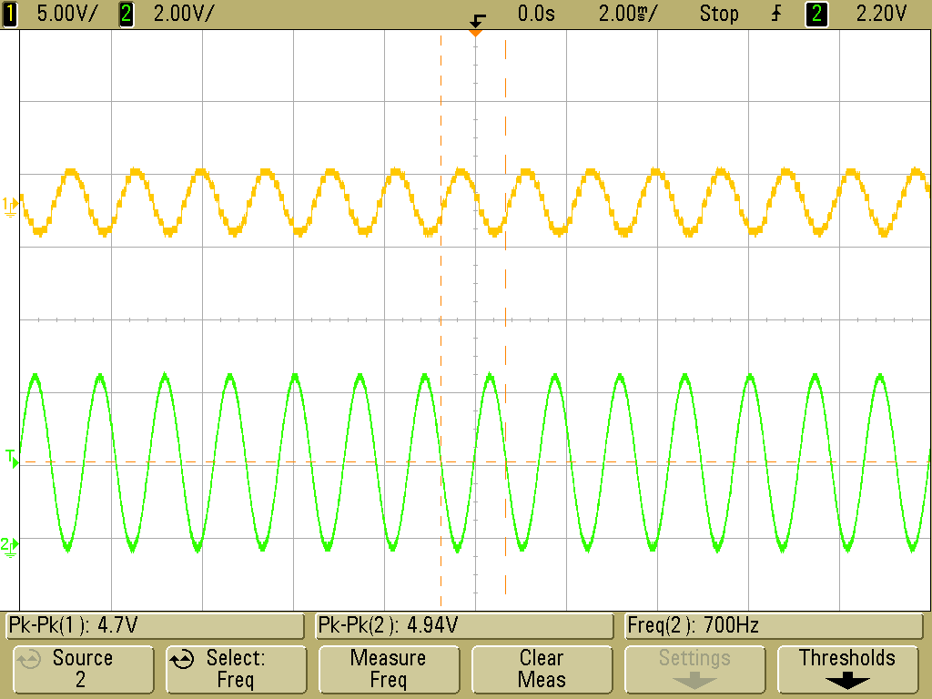

Figure 13: Output of Output amplifier with filtering Green is input into Attenuator Yellow is Output of Amplifier

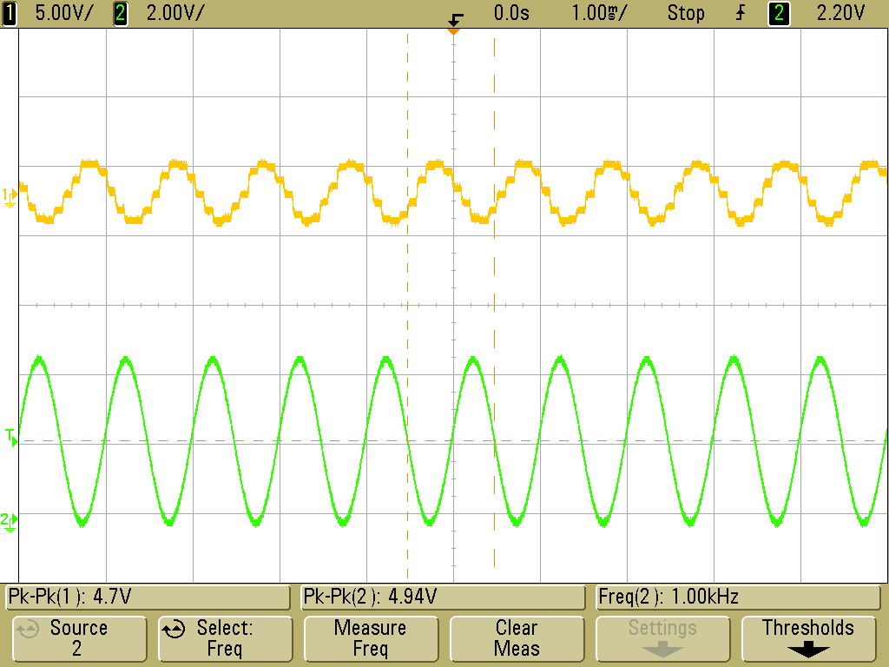

Figure 14: Output of Output amplifier with filtering Green is input into Attenuator Yellow is Output of Amplifier

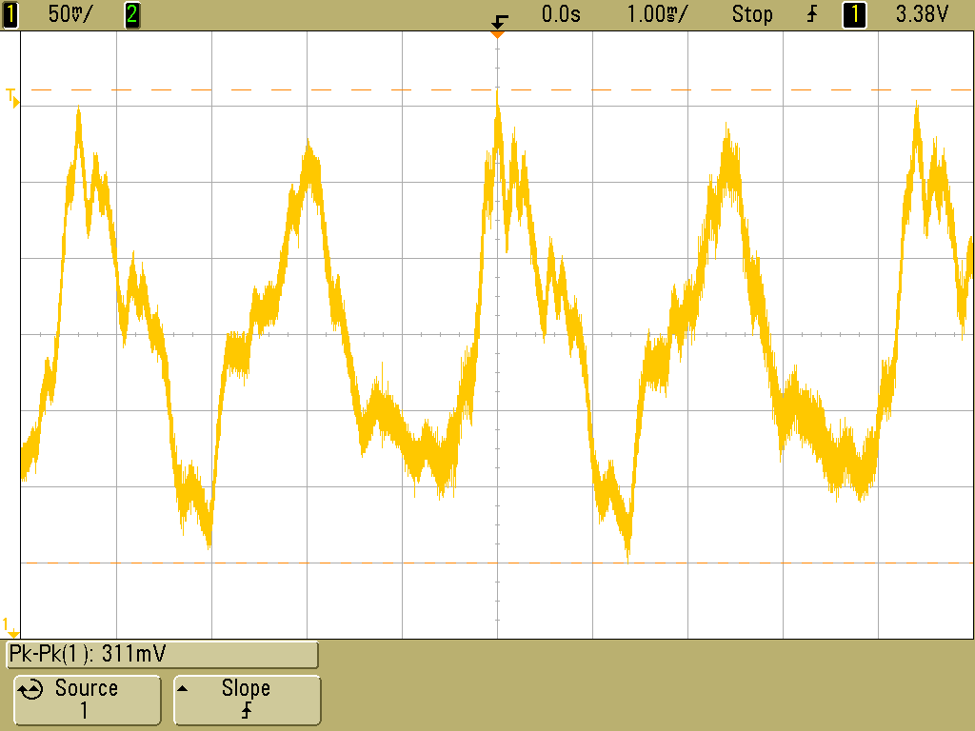

Figure 15:Vp-p of Microphone Output

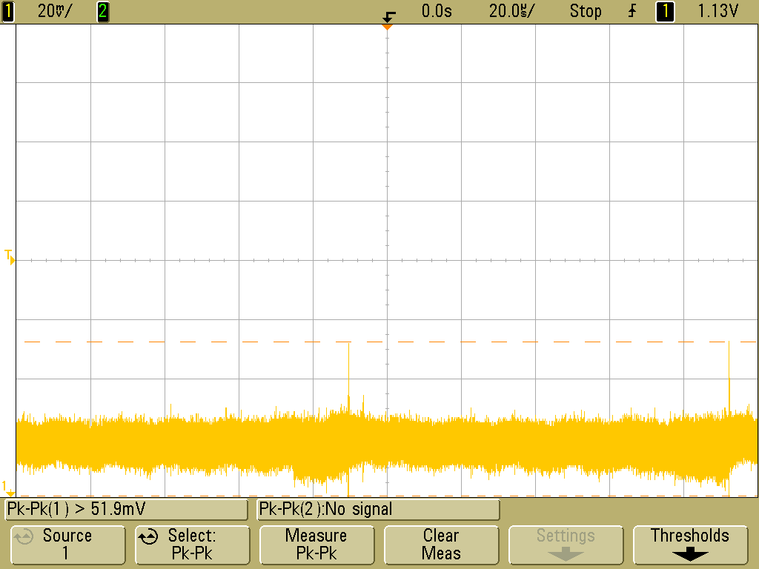

Figure 16: Vp-p of Microphone Output

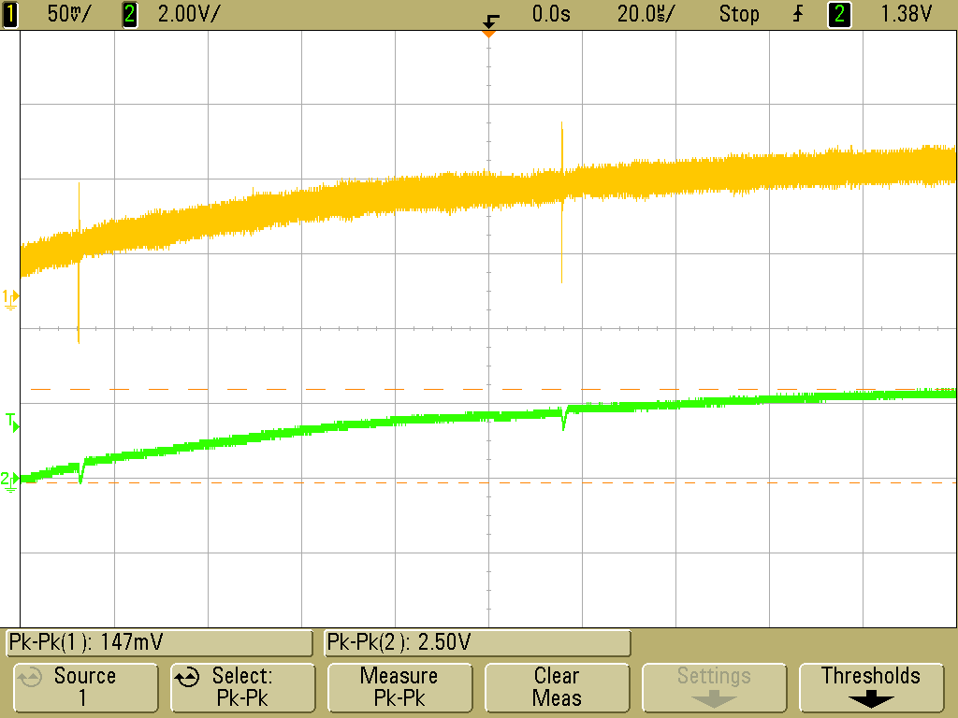

Figure 17: Output of Input Amplifier, Green is Output of the Amplifier and Yellow is the input

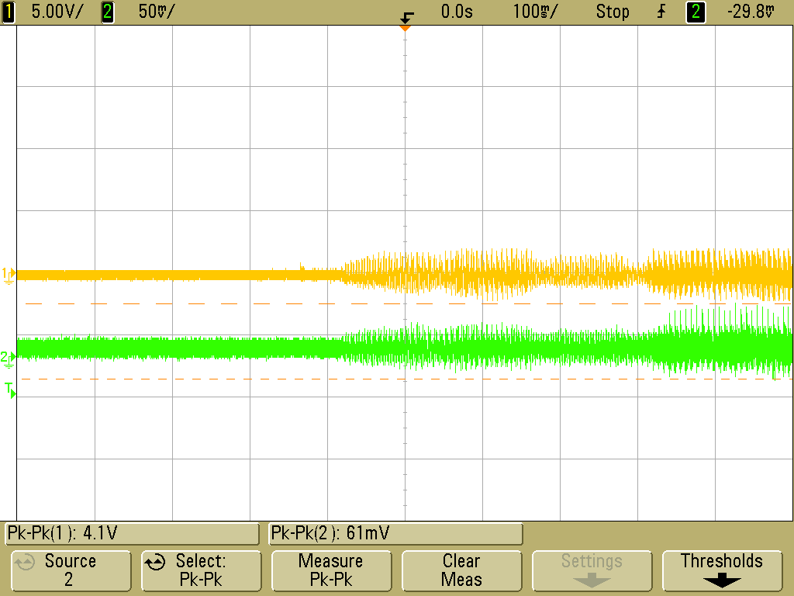

Figure 18: Output of Input Amplifier, Green is Input of the Amplifier and Yellow is the Output

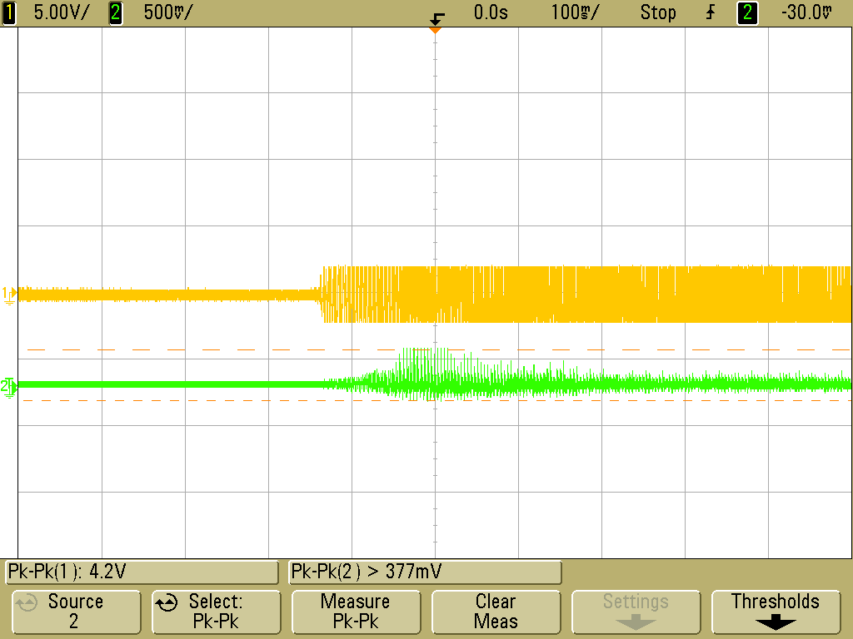

Figure 19: Input of Mic(Green) going into Input Amplifier then into the Output Amplifier Circuit (Yellow)

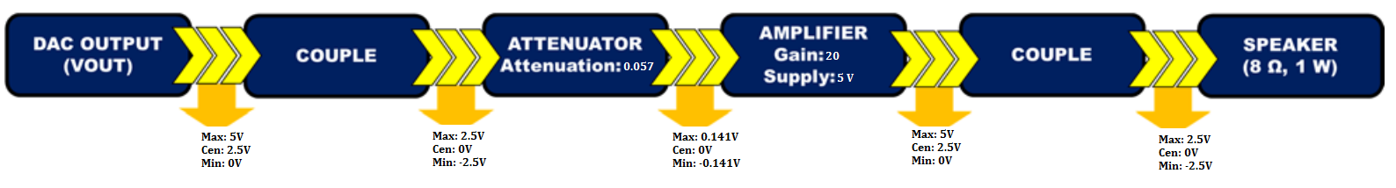

Figure 20: Design Flowchart for Output Amplifier

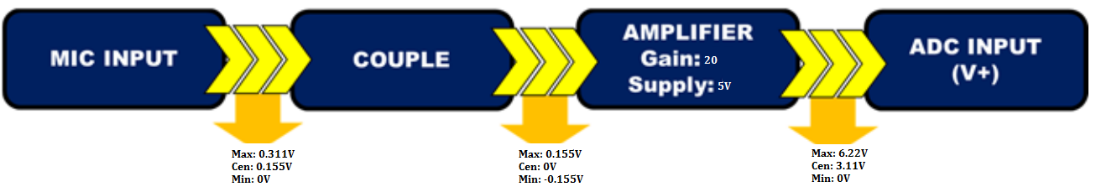

Figure 21: Design Flowchart for Input Amplifier

Equations

(1)

(2)

(3)

(4)

Tables

Table 1: Gain Table of LM386 using various Gain Resistors

|  |  |  |  |
| --- | --- | --- | --- |
| Gain Resistor (kΩ) | Input Voltage (V) | Output Voltage (V) | Gain |
| 1 | 0.116 | 2.8 | 24 |
| 5 | 0.119 | 3 | 25 |
| 10 | 0.116 | 3.1 | 26 |
| 20 | 0.116 | 3.4 | 29 |
| 50 | 0.281 | 5.2 | 18 |

Table 2: Voltage in to Attenuator vs Voltage Out of Output Amplifier

|  |  |  |  |
| --- | --- | --- | --- |
| Input Frequency (Hz) | Vin of Attenuator (V) | Vout of Output Amp (V) | Percent Error |
| 100 | 4.94 | 4.5 | 8.91% |
| 300 | 4.94 | 4.8 | 2.83% |
| 500 | 4.94 | 4.7 | 4.86% |
| 700 | 4.94 | 4.7 | 4.86% |
| 1000 | 4.94 | 4.7 | 4.86% |

**Explanations**

The first lab was to design a output amplification circuit as shown in Fig. 1. Before the amplification circuit can be designed the max input voltage to the speakers must need to be calculated. Using equation 4 the max voltage can be calculated, the speaker asked for a 1 W and 8-ohm impedance. Thus, the voltage rating of this speaker was calculated to be 5.64V. The LM386 amplification gain that was used was 20, this was chosen because it was the gain that was simplest to implement. Using this gain and speaker voltage spec an input to the amplifier needed to be around .282 V. To accomplish this an attenuator circuit was developed using equation 3 to achieve this voltage.

Once the design was completed, tests where done to verify the functionality of the LM386. Setting various gain resistors were chosen before permanently setting it to 20 and these tests can be seen in Fig. 4 through 5 and values of these tests can be seen in Table 1. The conclusion of these tests show a consistency with the resistance and the gain. Then the supply voltage was set to 5 V so that the speaker would not be blown. The function generator was connected to the attenuator and set to 5 V to emulate the output of the DAC. Fig. 9 through 14 represents the results. Table 2 Compares the input of the attenuator to the output of the amplifier. The lower frequencies show that there is about a 10 percent difference however this will not affect the performance. Closer to the mid-range of the human voice, the variation is only about 5%. Now that the speaker will not blow if plugged into the circuit the speaker was plugged in. As the frequency changed from the function generator the pitched would change too. The output amplifier was now completed.

The next lab the input amplification to the system was designed with the input to the amplifier being the mic as shown in Fig. 2 and 3. To apply the input into the amplifier a voltage diver with the microphone must be designed to apply the voltage needed into the amplifier. Since the impedance of the microphone was about 1 to 1.2 K ohms a proper resistor was used in series to get the targeted voltage. Figure 15 shows the max Vp-p of the microphone when it was screamed into, 311 mV. The ADC has a threshold of 0 – 5 V so the amplifier need to amplify the signal to about 5 V. As done in the first lab equation 3 was used to design the gain. The gain that was used was 25 for the given input from the microphone voltage divider. Fig. 21 shows the design process and the final values. Fig. 17 and 18 show the output of the circuit before any filtering was applied. The output of the amplifier showed both high and low frequencies, causing a lot of noise from the amplification. To combat this, noise a band pass filter was implemented to filter both high and low frequencies the high corner frequency of 4 KHz and a low frequency of around 150 Hz. The filter allowed the human voice frequency to pass without noise on the line. Using a voltage divider connected to the 5 V power supply a 2.5 V bias was applied to the signal.

Now both systems can where have connected to each other to test the input and output amplifications Fig. 19 shows the results of the speaking into the mic and the output to the speaker. The last step was to take the input amplifier and input it into the project board in V + and V -. Then the DAC output into the attenuator circuit that goes into the output amplifier then into the speaker. In all, the designed circuit was implemented and accomplished with minimal noise and proper volume. Hence, the audio recorder was successfully created after combining all the previous steps.